**Table 1. Characteristics of the study sample and standardized mean differences (SMD) between baseline PSU vs. no PSU at admission**

|  |  |  |  |  |  |
| --- | --- | --- | --- | --- | --- |
| **Variable** | **Category** | **No PSU (n=2,383)** | **PSU (n=10,934)** | **Overall (n= 13,317)** | **SMD** |
| Non-completion status of treatment (Dropout / Misspelled) (%) | 1 | 1833 (76.9) | 8615 (78.8) | 10448 (78.5) | 0.047 |
| Biopsychosocial compromise (Severe) (%) | 1 | 690 (29.0) | 4806 (44.0) | 5496 (41.3) |  |
| Treatment duration (binary) (<90 days) (%) | 1 | 567 (23.8) | 2702 (24.7) | 3269 (24.5) | 0.021 |
| Treatment duration (log-scaled days) (median [IQR]) |  | 5.1 [4.5, 5.6] | 5.1 [4.5, 5.7] | 5.11 [4.5, 5.7] | 0.043 |
| Age at admission to treatment (median [IQR]) |  | 37.1 [29.4, 46.2] | 31.4 [26.1, 38.1] | 32.18 [26.5, 39.6] | 0.542 |
| Birth year (median [IQR]) |  | 1976.0 [1968.0, 1984.0] | 1981.0 [1974.0, 1987.0] | 1981.0 [1973.0, 1986.0] | 0.446 |
| Primary substance (initial diagnosis): cocaine hydrochloride (%) | 1 | 108 (4.5) | 519 (4.7) | 627 (4.7) | 0.010 |
| Primary substance (initial diagnosis): cocaine base paste (%) | 1 | 251 (10.5) | 872 (8.0) | 1123 (8.4) | 0.088 |
| Primary substance (initial diagnosis): marijuana (%) | 1 | 483 (20.3) | 3865 (35.3) | 4348 (32.6) | 0.341 |
| Primary substance (initial diagnosis): alcohol (%) | 1 | 1484 (62.3) | 5440 (49.8) | 6924 (52.0) | 0.254 |
| Primary substance (initial diagnosis): other (%) |  | 57 (2.4) | 238 (2.2) | 295 (2.2) | 0.014 |
| Psychiatric comorbidity (ICD-10): In study (%) | 1 | 420 (17.6) | 2233 (20.4) | 2653 (19.9) | 0.071 |
| Psychiatric comorbidity (ICD-10): Diagnosis (%) | 1 | 986 (41.4) | 4850 (44.4) | 5836 (43.8) | 0.060 |
| Daily frequence of primary substance use at admission (%) | 1 | 1013 (42.5) | 5229 (47.8) | 6242 (46.9) | 0.107 |
| Occupational Status: Inactive (%) | 1 | 468 (19.6) | 1942 (17.8) | 2410 (18.1) | 0.048 |
| Occupational Status: Unemployed (%) | 1 | 764 (32.1) | 4507 (41.2) | 5271 (39.6) | 0.191 |
| Primary substance at admission to treatment: cocaine hydrochloride (%) | 1 | 292 (12.3) | 2078 (19.0) | 2370 (17.8) | 0.187 |
| Primary substance at admission to treatment: cocaine base paste (%) | 1 | 902 (37.9) | 5996 (54.8) | 6898 (51.8) | 0.346 |
| Primary substance at admission to treatment: marijuana (%) | 1 | 64 (2.7) | 653 (6.0) | 717 (5.4) | 0.162 |
| Primary substance at admission to treatment: alcohol (%) | 1 | 1082 (45.4) | 2062 (18.9) | 3144 (23.6) | 0.593 |
| Primary substance at admission to treatment: other (%) | 1 | 145 (1.3) | 43 (1.8) | 188 (1.4) | 0.039 |
| Treatment setting (%) | Basic ambulatory | 1040 (43.6) | 3320 (30.4) | 4360 (32.7) | 0.298 |
|  | GP intensive ambulatory | 786 (33.0) | 4212 (38.5) | 4998 (37.5) |  |
|  | GP residential | 272 (11.4) | 1906 (17.4) | 2178 (16.4) |  |
|  | WO intensive ambulatory | 138 (5.8) | 607 (5.6) | 745 (5.6) |  |
|  | WO residential | 147 (6.2) | 889 (8.1) | 1036 (7.8) |  |

Note. n= frequency of patients; descriptive statistics of baseline characteristics used the median (Q2) and percentiles 25 and 75 in brackets for continuous variables. Furthermore, categorical variables are represented in frequencies and percentages (%) in parenthesis.

**Figure 1. Percentage distribution of treatment outcomes by baseline treatment setting and polysubstance use status**

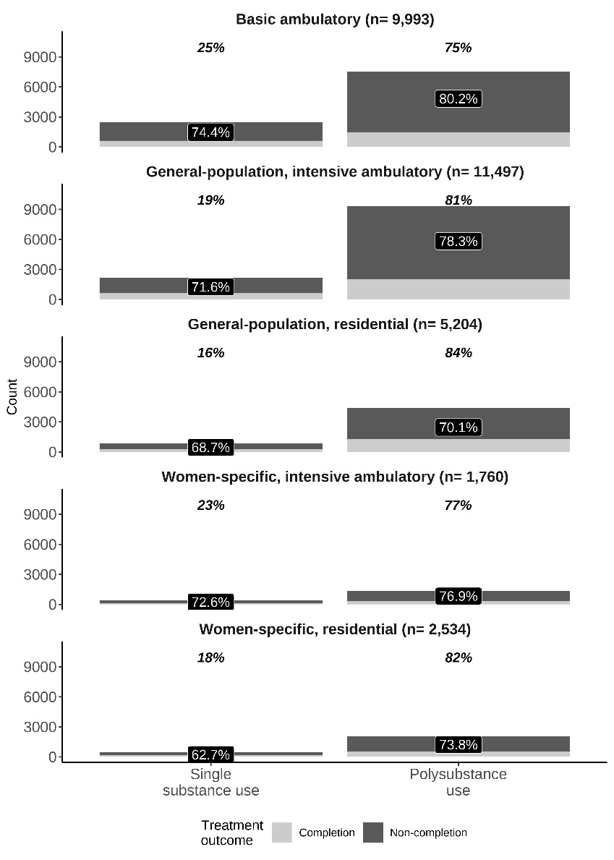

Note. n stands for the number of treatment episodes in each treatment setting at baseline; percentages of treatment non-completion within polysubstance use status and baseline treatment setting are labelled inside the bars; italicized and bold percentages above the bars indicate the overall percentages of single substance use and polysubstance use for each baseline treatment setting.

**Table 2. Incidence rates (per 1.000 person-months)**

|  |  |  |  |  |
| --- | --- | --- | --- | --- |
| **Type** | **Polysubstance use** | **Follow-up time** | **Events** | **IR (95% CI)** |
| PSU at admission and at least one event of non-completion | Not reported | 161,852.30 | 2,135 | 13.19 (12.64, 13.76) |
|  | Reported | 872,863.25 | 10,085 | 11.55 (11.33, 11.78) |
| PSU at admission and event of non-completion at first treatment | Not reported | 161,852.30 | 1,833 | 11.33 (10.81, 11.86) |
|  | Reported | 872,863.25 | 8,615 | 9.87 (9.66, 10.08) |
| At least one treatment reporting PSU and at least one event of non-completion | Not reported | 78,926.85 | 1,099 | 13.92 (13.11, 14.77) |
|  | Reported | 955,788.69 | 11,121 | 11.64 (11.42, 11.85) |
| At least one treatment reporting PSU and event of non-completion at first treatment | Not reported | 78,926.85 | 936 | 11.86 (11.11, 12.64) |
|  | Reported | 955,788.69 | 9,512 | 9.95 (9.75, 10.15) |

Note. incidence rate (IR) along with the 95% confidence interval (95% CI).

**Table 3. Association between Polysubstance use at admission and Treatment noncompletion** **status (dropout or spelled by misconduct) from Poisson Regression Multivariable Model with independence structure**

|  |  |  |  |
| --- | --- | --- | --- |
| **Baseline treatment setting** | **Inverse intensity weighted RR (95%CI) (lag0)** | **Inverse intensity weighted RR (95%CI) (lag1)** | **RR (95%CI)** |
| Basic ambulatory |  |  |  |
|  | 1.02 (0.99, 1.05) | 1.02 (1.00, 1.05) | 1.03 (1.00, 1.05) |
| General-population, intensive ambulatory |  |  |  |
|  | 1.04 (1.01, 1.08) | 1.04 (1.01, 1.07) | 1.04 (1.01, 1.07) |
| General-population, residential |  |  |  |
|  | 0.97 (0.92, 1.02) | 0.95 (0.90, 1.01) | 0.97 (0.92, 1.02) |
| Women-only, intensive ambulatory |  |  |  |
|  | 0.99 (0.92, 1.07) | 0.99 (0.92, 1.06) | 0.99 (0.93, 1.05) |
| Women-only, residential |  |  |  |
|  | 1.15 (1.06, 1.25) | 1.13 (1.04, 1.22) | 1.14 (1.06, 1.23) |

Note. RR= Relative risk; 95%CI= 95% confidence intervals in parenthesis; lag0: Lagged covariates were fixed to 0 for binary variables and natural logarithm of 45 days; lag1: Lagged covariates were fixed to 1 for binary variables and natural logarithm of 90 days.

All models adjusted for the following covariates: biopsychosocial compromise (severe status) at admission to treatment, Age at admission to treatment, Birth year, Primary substance of the initial diagnosis (cocaine hydrochloride, cocaine base paste, marijuana, and other substances), Psychiatric comorbidity (in study and with comorbidity), Daily frequence of primary substance use at admission, Occupational status (inactive and unemployed), Primary substance at admission to treatment (Cocaine hydrochloride, cocaine base paste, marijuana, and other substances).